Given a circle represented as (radius, x_center, y_center) and an axis-aligned rectangle represented as (x1, y1, x2, y2), where (x1, y1) are the coordinates of the bottom-left corner, and (x2, y2) are the coordinates of the top-right corner of the rectangle.

Return True if the circle and rectangle are overlapped otherwise return False.

In other words, check if there are **any**point (xi, yi) such that belongs to the circle and the rectangle at the same time.

**Example 1:**

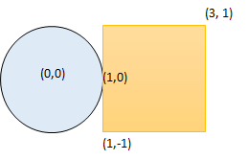

**Input:** radius = 1, x_center = 0, y_center = 0, x1 = 1, y1 = -1, x2 = 3, y2 = 1

**Output:** true

**Explanation:** Circle and rectangle share the point (1,0)

**Example 2:**

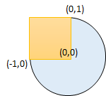

**Input:** radius = 1, x_center = 0, y_center = 0, x1 = -1, y1 = 0, x2 = 0, y2 = 1

**Output:** true

**Example 3:**

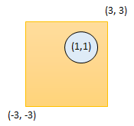

**Input:** radius = 1, x_center = 1, y_center = 1, x1 = -3, y1 = -3, x2 = 3, y2 = 3

**Output:** true

**Example 4:**

**Input:** radius = 1, x_center = 1, y_center = 1, x1 = 1, y1 = -3, x2 = 2, y2 = -1

**Output:** false

**Constraints:**

* 1 <= radius <= 2000
* -10^4 <= x_center, y_center, x1, y1, x2, y2 <= 10^4
* x1 < x2
* y1 < y2